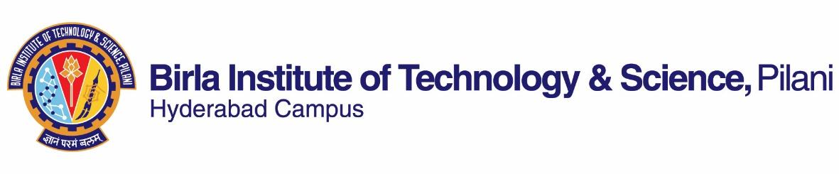

**SECOND SEMESTER 2021-2022**

# Course Handout Part II

Date: 15-01-2022

In addition to part-I (General Handout for all courses appended to the time table) this portion gives further specific details regarding the course.

**Course No. : CHE F244**

## **Course Title : Separation Processes I**

## **Instructor-in-Charge : Dr. Satyapaul A. Singh**

**Scope and Objective of the Course:**

This course is designed to understand the mass transfer operations by applying the principles of molecular and interphase mass transfer. As a part of Separation Processes I, students apply the physical understanding about mass transfer operations and learn the design approach for absorption, distillation, extraction and leaching.

**Content:**

Molecular diffusion in fluids, Interphase mass transfer, mass transfer coefficient, Theories for interphase mass transfer, overall mass transfer coefficient and correlations, mass transfer with chemical reaction, analogy between momentum, heat and mass transfer, Absorption, Distillation including azeotropic and extractive distillation, Liquid-Liquid extraction, Leaching, Equipment for absorption, distillation, extraction and leaching.

**Textbooks:**

T1 – Robert E. Treybal, “Mass Transfer Operations”, McGraw Hill, 3rd Edition (1981).

T2 – J. D. Seader and Ernest J. Henley, “Separation Process principles” John Wiley & Sons, Inc, 2nd Edition (2006).

**Reference books:**

R1 – Binay K. Dutta,“Principles of mass transfer and separation processes”, PHI Learning Pvt Ltd, (2007).

R2 - McCabe, W. L., Smith, J. C., Harriott, P., “Unit Operations of Chemical Engineering”, McGraw-Hill, 7th Edition, (2005).

**Course Plan:**

|  |  |  |  |
| --- | --- | --- | --- |
| **Lecture No.** | **Learning objectives** | **Topics to be covered** | **Chapter in the Text Book** |
| 1 | Introduction to separation processes | Unit operations and unit process, Basic concepts | Ch. 1 T1,T2 |
| 2-5 | Molecular diffusion in fluids | Molecular diffusion and fluxes,  Molecular diffusion in Gases (stagnant film, equimolal counter diffusion), Diffusivity of gases and liquids. | Ch. 2, T1  Ch. 3 T2 |
| 6-14 | Mass transfer coefficients, interphase mass transfer | Relations between mass transfer coefficients, Reynolds analogy.  Equilibrium, diffusion between phases, material balances, stages. | Ch. 3, 5 T1  Ch. 3 T2 |
| 15-22 | Gas absorption  (Equipment for absorption) | Equilibrium solubility of gases in liquids, one component transfer: material balance for counter – and co-current processes, multi stage operations, non-isothermal operations, calculation of height of packed absorber/desorber, multi-component systems, absorption with chemical reaction. | Ch. 6T1 |
| 23-35 | Distillation  (Equipment for distillation) | Vapor-liquid equilibrium, flash vaporization, differential distillation, Continuous distillation, multistage columns, overall mass and enthalpy balances, McCabe-Thiele method, Ponchon-Savarit method, use of open steam, multiple feed, side streams, azeotropic and extractive distillations. | Ch. 9 T1  Ch. 7 T2 |
| 36-39 | Liquid extraction  (Equipment for extraction) | Liquid-liquid equilibrium, distribution curves, triangular and solvent free coordinates, systems of three liquids-one pair partially soluble, insoluble liquids, effect of temperature, continuous counter-current multi-stage extraction, continuous counter-current extraction with reflux. | Ch. 10, T1 |
| 40-42 | Leaching (Equipment for leaching) | Solid-liquid extraction, underflow and overflow locus, Multistage cross current extraction, Calculation of no. of stages for cross current flow. | Ch.13, T1 |

**Evaluation Scheme:**

|  |  |  |  |  |
| --- | --- | --- | --- | --- |
| **Component** | **Duration** | **Weightage (%)** | **Date & Time** | **Nature of Component** |
| Assignments (2) | (Will be discussed in Tutorial Sessions) | 15 | TBA | Open Book |
| Quiz (3) | In regular lectures & tutorials | 15 | TBA | Open Book |
| MID | 1.5 h | 30 | 10/03 9.00am to10.30am | Open Book |
| Comprehensive Exam | 2 h | 40 | 06/05 FN | Open Book |

**Chamber Consultation Hour:** At 5 PM on every Tuesday (Chamber: **D 204**).

**Notices:** Will be updated via CMS/Google Classroom/Email

**Make-up Policy:** Make-up will be granted only for genuine cases with valid justification and only with prior permission of Instructor-in-charge.

**Academic Honesty and Integrity Policy**: Academic honesty and integrity are to be maintained by all the students throughout the semester and no type of academic dishonesty is acceptable.

**Dr. Satyapaul A. Singh**

**INSTRUCTOR-IN-CHARGE**

**CHE F244**